**Introduction/Business Problem:**

My client is a world-renowned pizza connoisseur that reviews pizza places around the world. His next destination is the US and he has never been there before. He wants to be in a city where there is a high density of pizza places so that he can find out the best pizza that city can offer. Due to the short duration of his trip, his ideal city would be one that has a high density of pizza places within a short distance of his hotel. This way he can have utilize his trip in which he will be able to visit a large amount of pizza places in a small amount of time.

In order to solve this problem, I will have to perform an analysis of the pizza store locations in major US cities and find out which city would be the most ideal for my client to perform his review of the best pizza place in that particular city.[¶](https://dataplatform.cloud.ibm.com/data/notebooks/converter/assets/80888a96-3dc6-4b2a-9187-2d03f059a73f?project=d0fe4723-4640-47d4-a633-eb832d99edaf" \l "In-order-to-solve-this-problem,-I-will-have-to-perform-an-analysis-of-the-pizza-store-locations-in-major-US-cities-and-find-out-which-city-would-be-the-most-ideal-for-my-client-to-perform-his-review-of-the-best-pizza-place-in-that-particular-city.)

**Data Section:**

### In order to address the aforementioned problem, I will use the Foursquare API for data collection of the locations of pizza stores in five US major cities which are :

### 1)New York, NY,

### 2)San Francisco, CA,

### 3)Jersey City, NJ,

### 4)Boston, MA

### 5)Chicago, IL.

### These cities are some of the most populated cities in the US. Thus, they have a high potential of having a large density of pizza places so that my client can perform his pizza review adequately. I will be using the Foursquare API to determine which of the five aforementioned cities has the highest volume of pizza places. By doing so, I can narrow down which city will be having the most pizza places suitable for my client to perform his review by eating at the many pizza places that city has to offer.

**Methodology:**

I need to asses which of the five major cities listed would have the largest pizza store density. Firstly, I used the Foursquare API through the venues channel. I used the ‘near’ query to get venues in the five major cities. Also, I used the Category ID corresponding to pizza places on foursquare to filter out the required venue category.

**Example of my Foursquare request:**

**https://api.foursquare.com/v2/venues/explore?&client_id=&client_secret=&v=20180605&New York, NY&limit=100&categoryId=4bf58dd8d48988d1ca941735**

The category id in the above link (**4bf58dd8d48988d1ca941735**) corresponds to the venue category of “pizza Place” on Foursquare.

I performed the aforementioned request for the 5 major cities I listed and got their top 100 venues. Furthermore, to get a proper indication of the density level of pizza places in the cities, I used statistical methods to calculate a center coordinate of the venues to get the mean longitude and latitude values. Lastly, I calculated the mean of the Euclidean distance from each venue to the mean coordinates. As a result, I was able to figure out the mean distance to the mean coordinate for each city and this illustrates the density of the pizza places in each of the five cities.

**Results:**

Using folium, I was able to generate visual illustration of maps with the pizza places marked. The following are the geoplots generated with folium :

**New York City:**

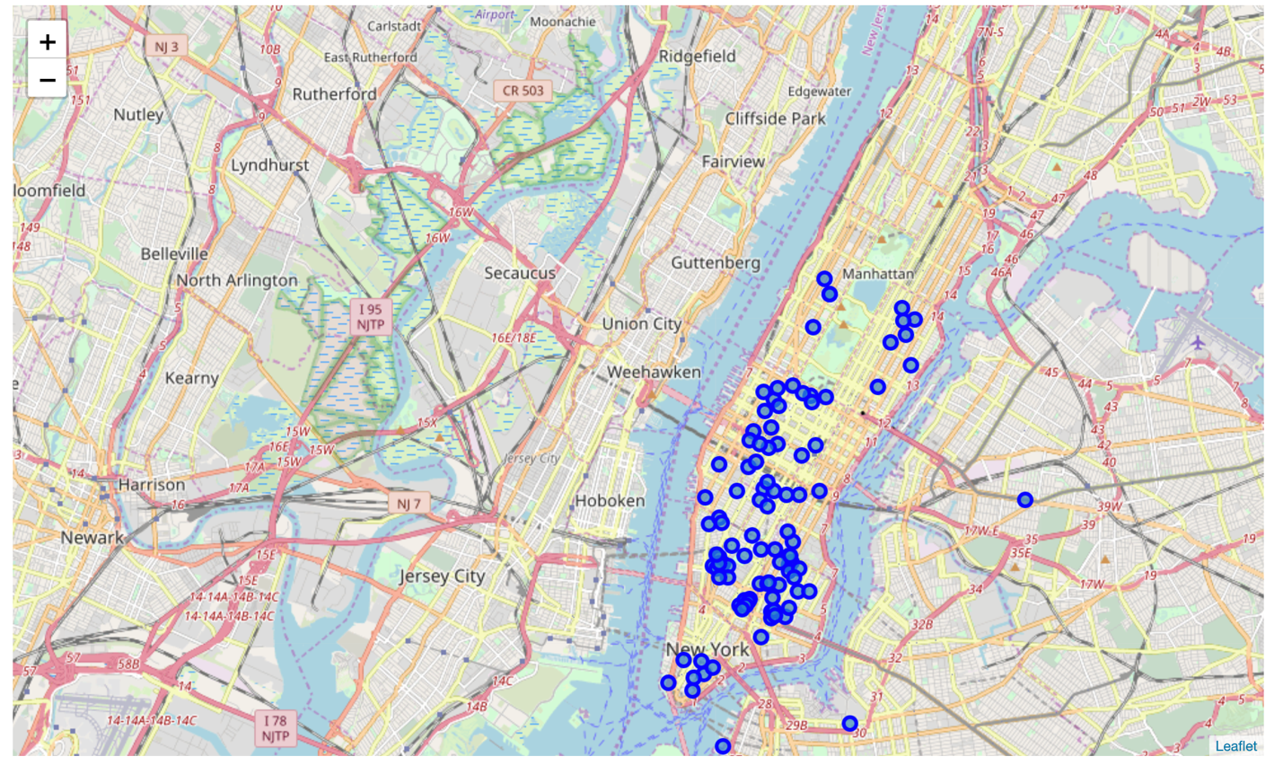

**Chicago:**

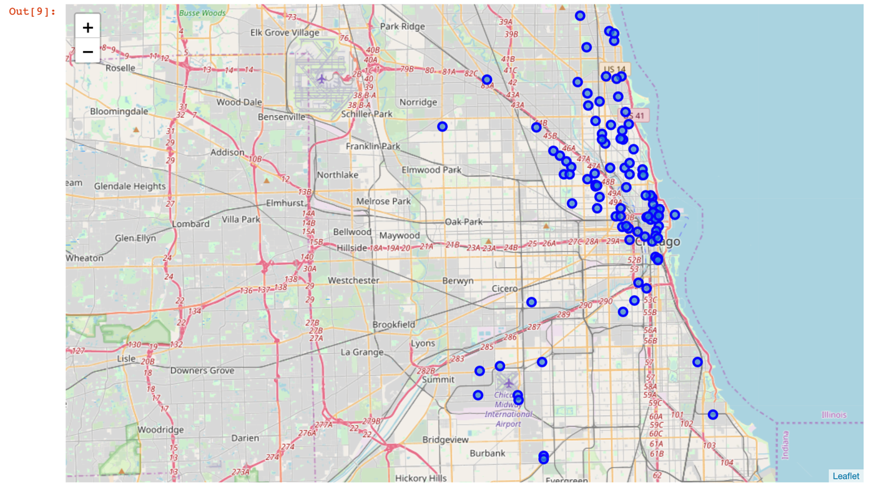

**San Francisco:**

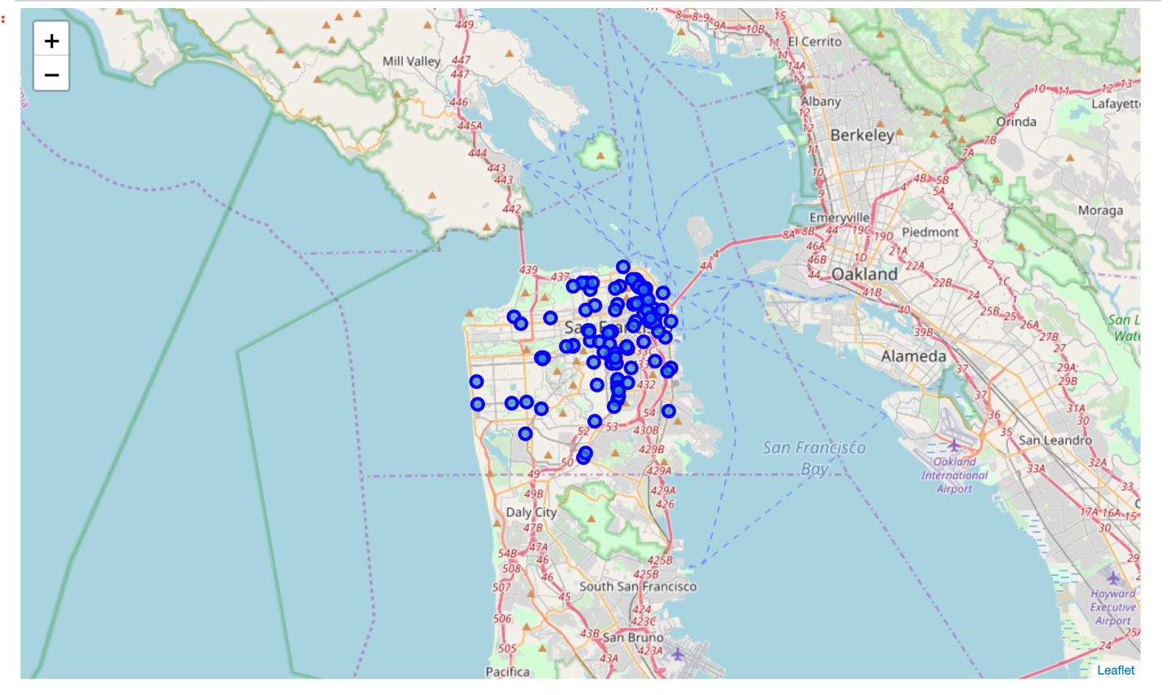

**Jersey City:**

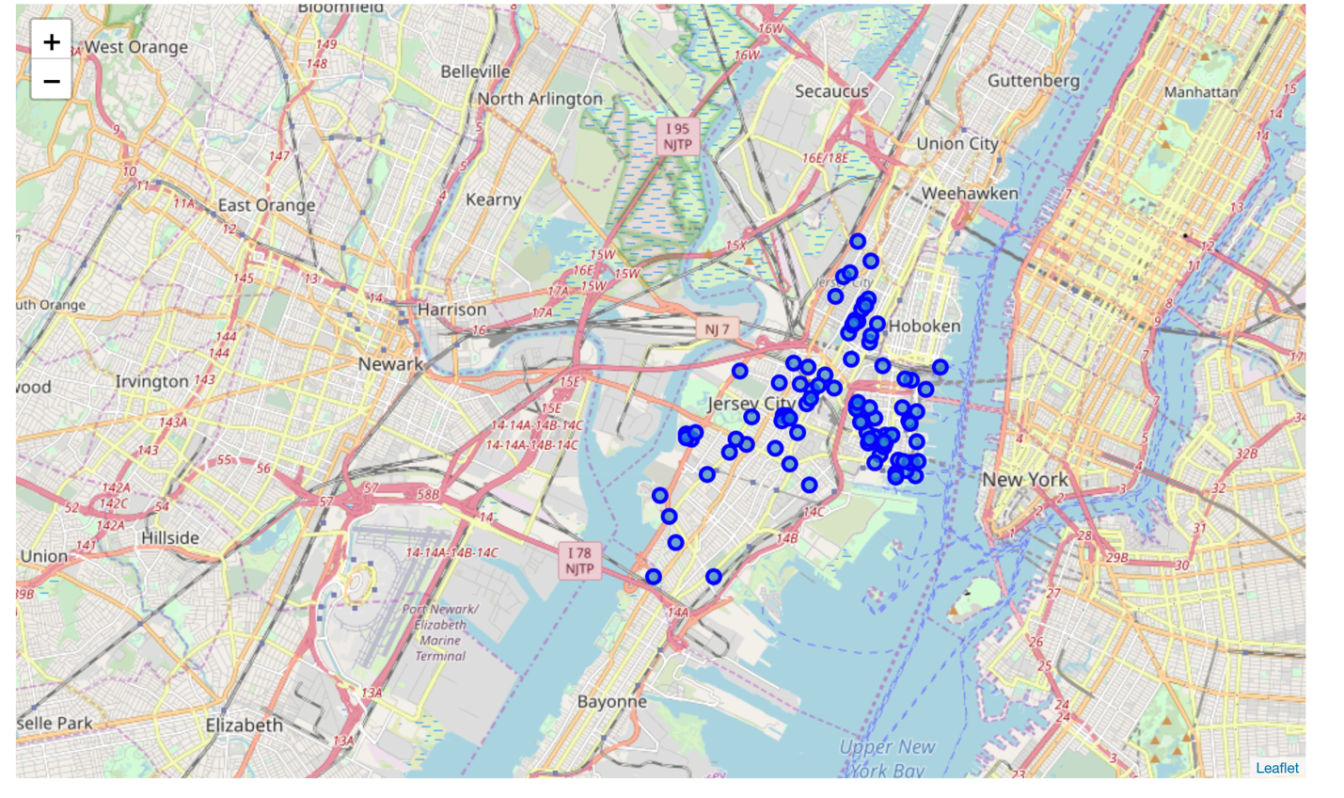

**Boston:**

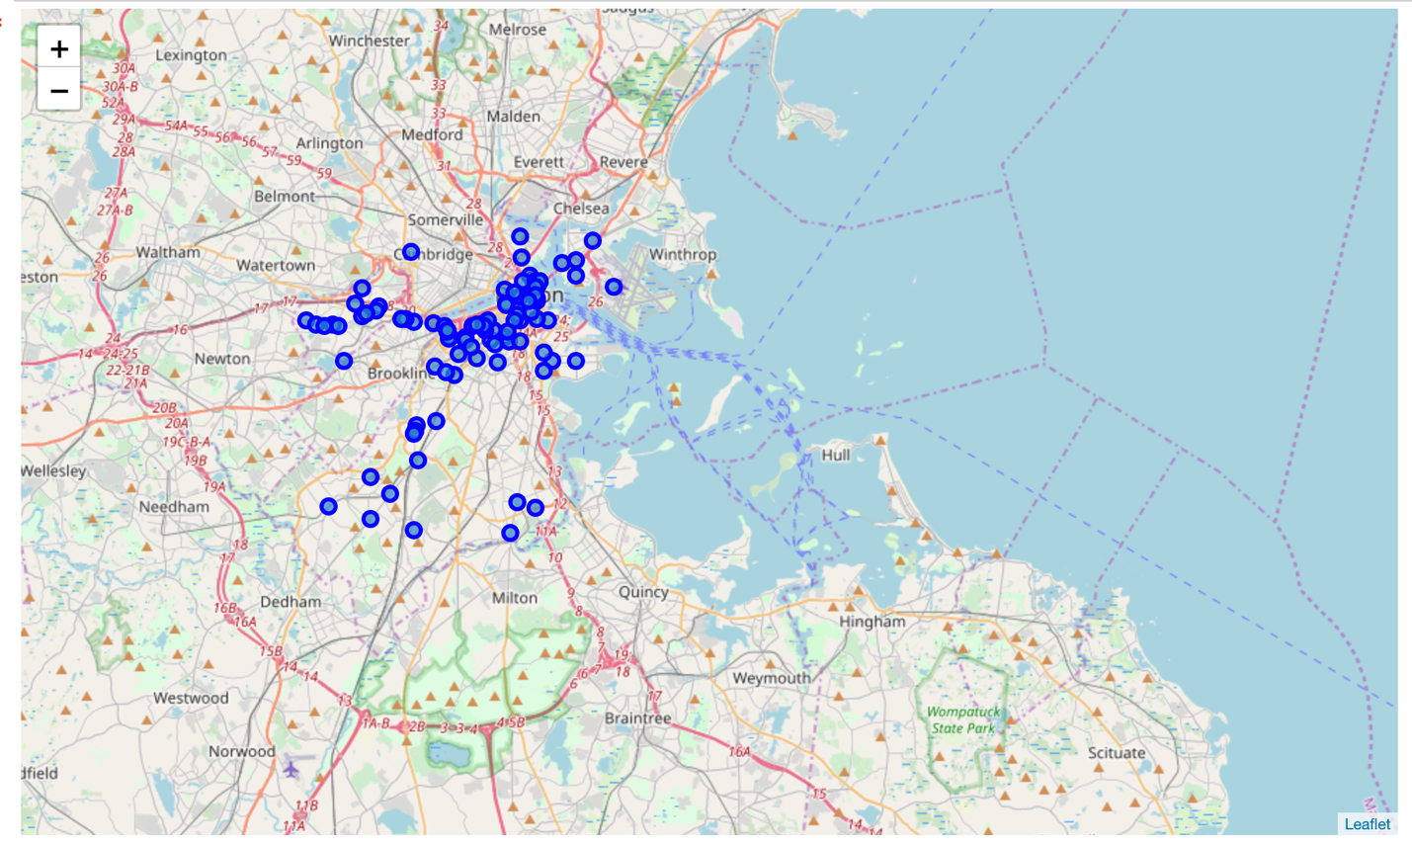

Through visual inspection of the maps of the five cities, we can see that New York, San Francisco, and Jersey City are the densest cities in terms of pizza places. Next, I will calculate the mean coordinate and the mean distance to mean coordinate(MDMC). As show below the mean coordinate is illustrated by a green circle and the distance from this mean coordinate with green lines.

**New York City:**

Mean Distance from Mean coordinates

0.02222289381011469

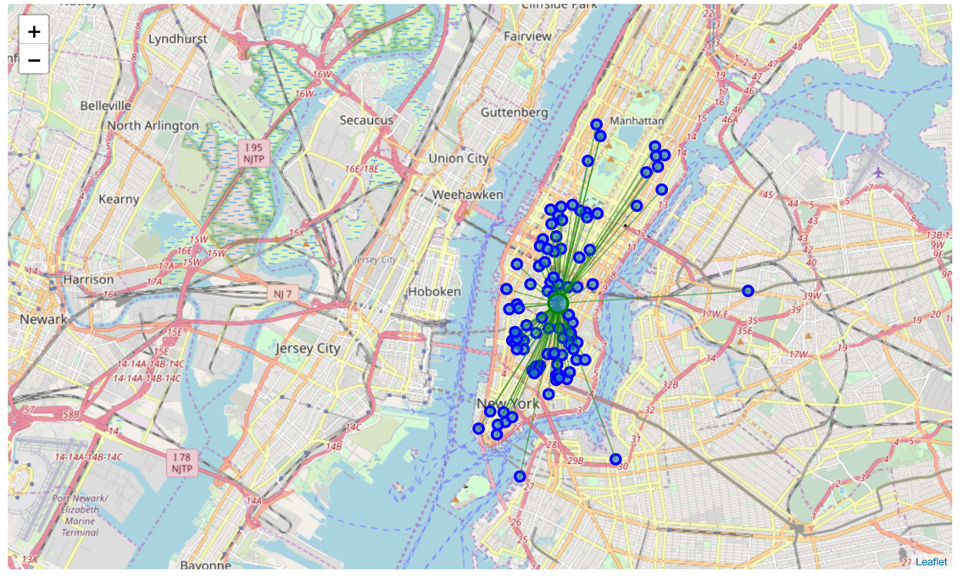

**Chicago:**

Mean Distance from Mean coordinates

0.0589039075521342

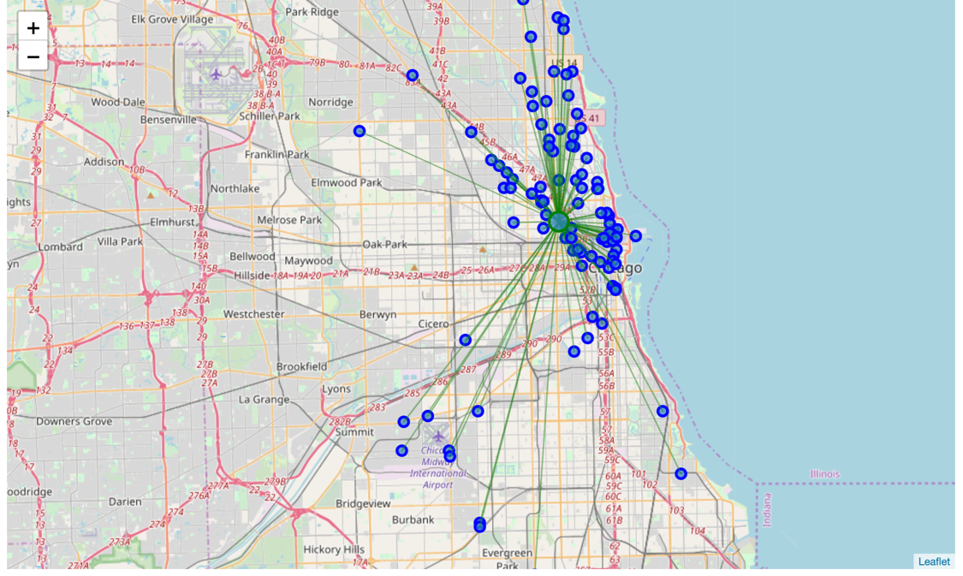

**San Francisco:**

Mean Distance from Mean coordinates

0.028626658072997885

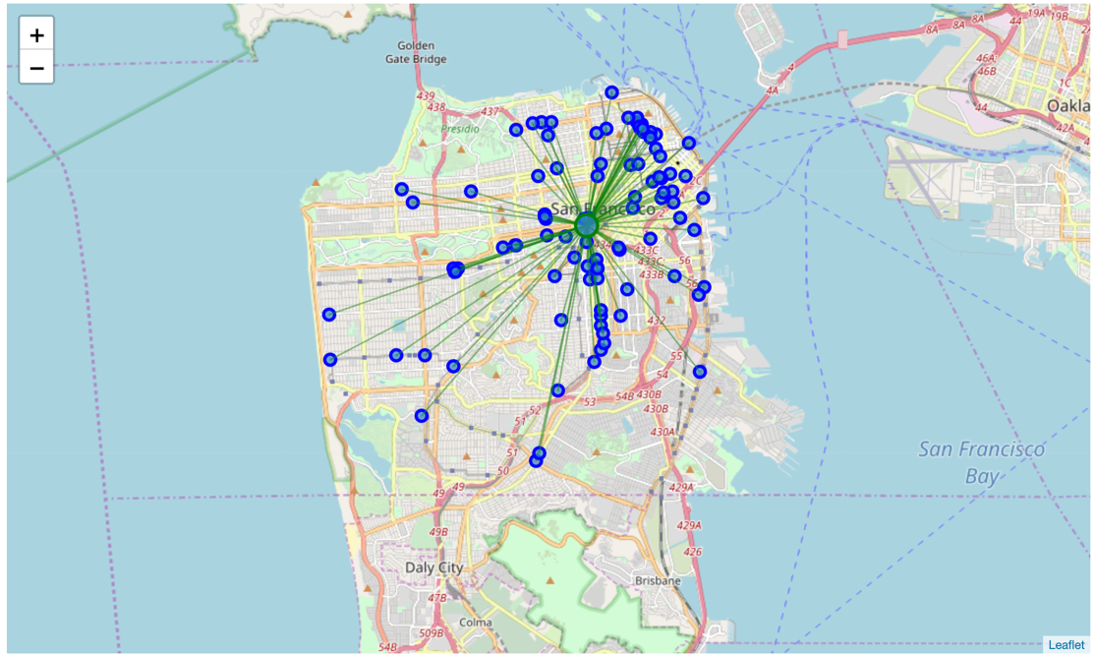

**Jersey City:**

Mean Distance from Mean coordinates

0.019445551195654404

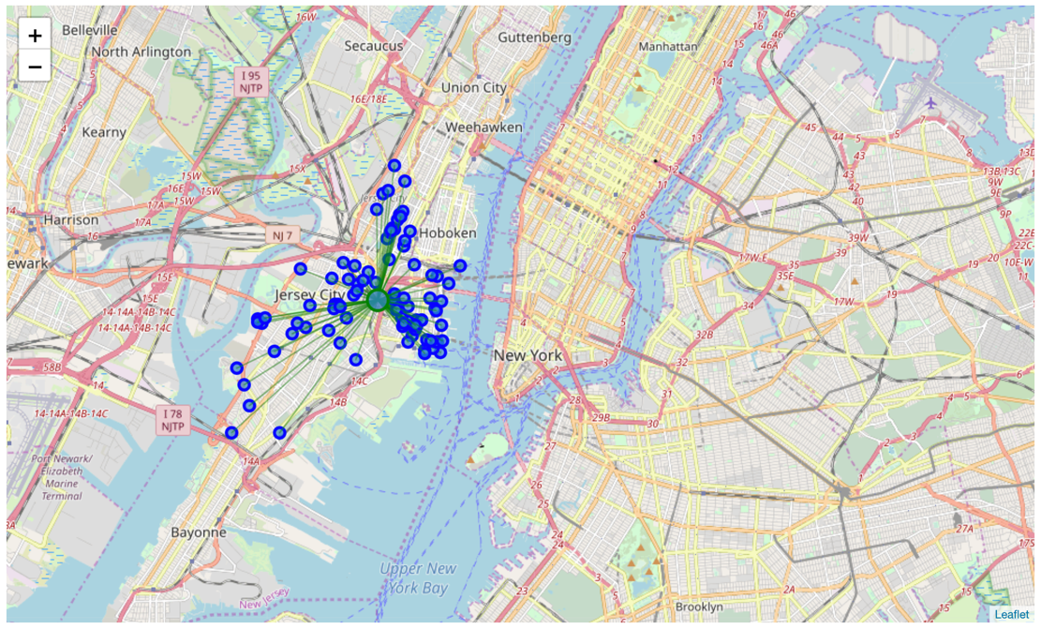

**Boston:**

Mean Distance from Mean coordinates

0.03574459449909179

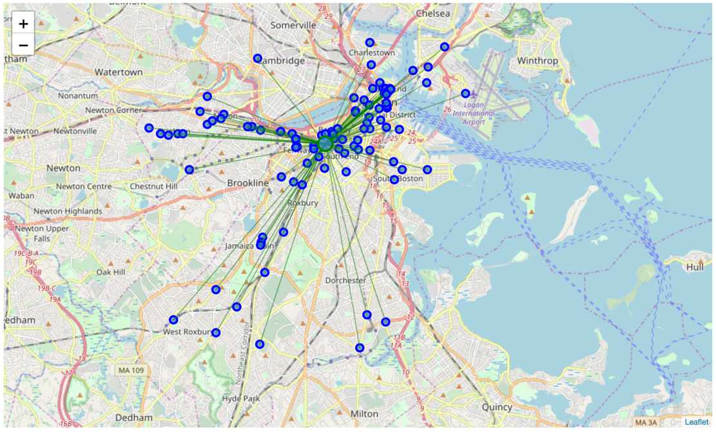

**Based on my findings, the results from highest(1) to lowest density(5)of pizza places is the following:**

1. New York
2. San Francisco
3. Jersey City
4. Boston
5. Chicago

**Discussion:**

Based on my observation of the maps generated and the mean distance from mean coordinate. My client’s best bet would be to go to New York City for his pizza reviews. I would not recommend him going to Chicago because it is the least dense with regards to pizza places and therefore, he will not be able to perform as many reviews in the short period of time he is visiting for.

**Conclusion:** I can safely conclude that New York City is the best place for our pizza connoisseur to try as many pizzas as he can and perform reviews to figure out the best pizza places due to New York City’s having the densest amount of pizza places. Also, I would recommend that the pizza connoisseur book his hotel close to the mean coordinate illustrated by the green circle in the aforementioned New York map such that he has convenient access to all of those pizza places nearby.